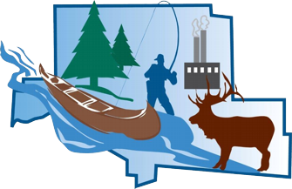
Elk County Fair Open Horse Show
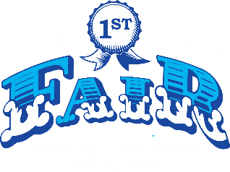
August 10, 2024 Starting at 9am
Elk County Fairgrounds
316 Dietz Road Kersey, PA 15846
Gates to open at 7:30 AM
Judge: Emily Fowler

Entry Fee to show is $6 per class or show all day for $35 (per horse/rider combo). Grounds Fee is $3 per horse/pony. Cloverbud class fees are $4 per class. The Grounds Fee will be waived for horses on display in the Horse Barn during Fair Week. Any contestant under the age of 19 years old MUST wear an equine riding helmet that is ASTM/SEI approved. The show will follow PA 4-H rules as guidelines. The show committee reserves the right to combine, split or cancel any classes with less than 3 entries. The Elk County Fair or any of its volunteers will not be responsible for any accidents or injuries to any animal or person (this also includes any damages). The event falls under the protection of the Pennsylvania Equine Law - Purdon’s Pennsylvania Statutes and Consolidated Statutes Annotated. Title 4 P.S. Amusements. Chapter 13. Equine Activity. (4 P.S. § 601-607). Gate admission is required for everyone. Exhibitors will receive a refund certificate. Certificates may be redeemed at the Fair Office or as directed by Fair Officials before the conclusion of today’s Fair Business Hours.

STALLS WILL NOT BE AVAILABLE
Junior: 8 thru 15 years of age Senior: 16 year of age and older
Cloverbud: 5 -7 years of age Walk/Trot: Any age (no cantering)
Classes listed in Bold are premium classes. Premium awards are as follows:
- Premium classes with 5 or less entries will receive 1st place-$5, 2nd place-$3 & 3rd place-$1.
- Premium classes with 6 or more entries will receive 1st place-$10, 2nd place-$ & 3rd place-$5
If you have any questions please call or text (814) 512-4169

Show Schedule
1. Grooming & Showmanship-Junior 17. Open Pleasure-Cloverbud
2. Grooming & Showmanship-Senior ***10 Minute English Warm Up**
3. Grooming & Showmanship-Cloverbud 18. English Pleasure-Junior
4. Halter – Geldings 19. English Pleasure-Senior
5. Halter – Mares 20. English Pleasure-Walk/Trot
6. Open Driving: A) Draft B) Pony C) Mini 21. English Equitation-Junior
**10 Minute Western Warm Up** 22. English Equitation-Senior
7. Western Pleasure – Junior 23. English Equitation-Walk/Trot
8. Western Pleasure – Senior 24. Horsemanship/Equitation - Cloverbud
9. Western/Ranch Pleasure – Walk/Trot 25. Hunter Hack-Horse/Pony
10. Ranch Pleasure – Junior 26. Working Hunter
11. Ranch Pleasure – Senior 27. In-Hand Trail (Miniature/Yearling)
12. Western Horsemanship-Junior 28. Open Trail-Cloverbud
13. Western Horsemanship-Senior 29. Open Trail-Junior
14. Western Horsemanship-Walk/Trot 30. Open Trail-Senior
15. Reining (Novice) 31. Open Trail-Walk/Trot
16. Ranch Riding 32. Miniature Horse Jumping

No refunds will be given when an exhibitor scratches or forfeits any class(es)

